**NAME: BINYANYA DEBORAH NYATICHI**

**CS NO: ADC-CSS02-25051**.

**DESCRIPTION: Week 5: Secure Identity and Access**

**ASSIGNMENT: Assignment 9: Lab - Role-Based Access Control**

**DATE: 14/05/2025**

# INTRODUCTION

In this lab, I will be working on implementing Role-Based Access Control (RBAC) in a cloud environment to enhance security and streamline user permissions. Specifically, I will create three separate security groups—Senior Admins, Junior Admins, and Service Desk—each containing a designated user: Joseph Price, Isabel Garcia, and Dylan Williams, respectively. After establishing the groups and assigning the correct users, I will apply the Virtual Machine Contributor role to the Service Desk group. This exercise aims to demonstrate how to manage access control effectively by granting the right level of permissions to users based on their roles within an organization.

# ROLE-BASED ACCESS CONTROL

## Lab Setup

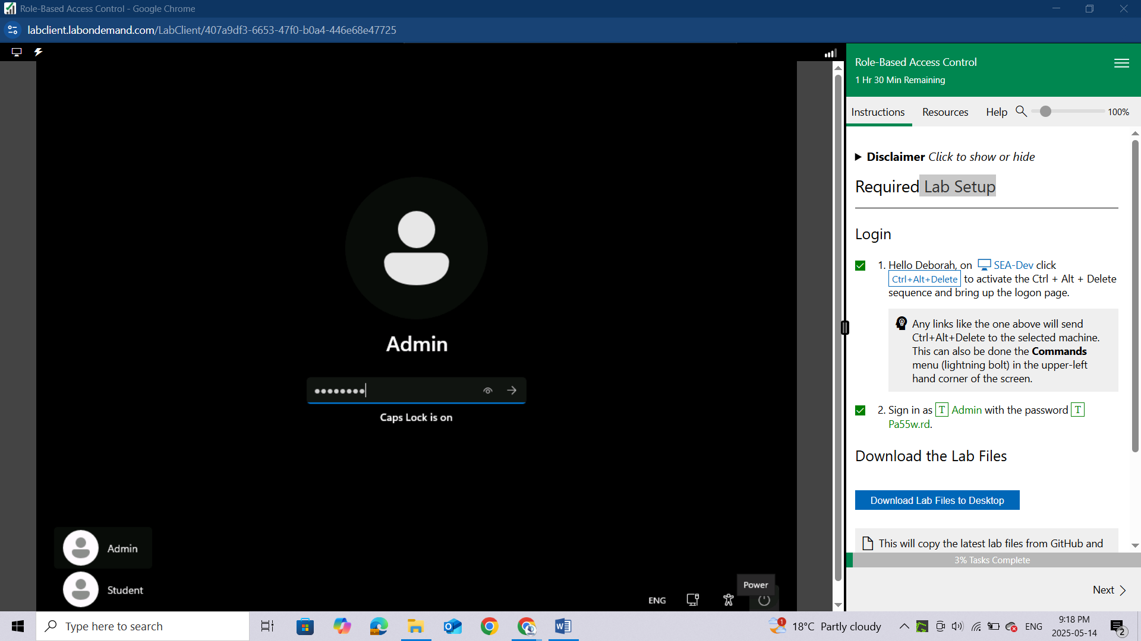

## Download the Lab Files

Download the files from the link provided in the lab setup

After successful download you will see a green bar of “***SUCCESS! The Lab Files have been downloaded to the Desktop.***”

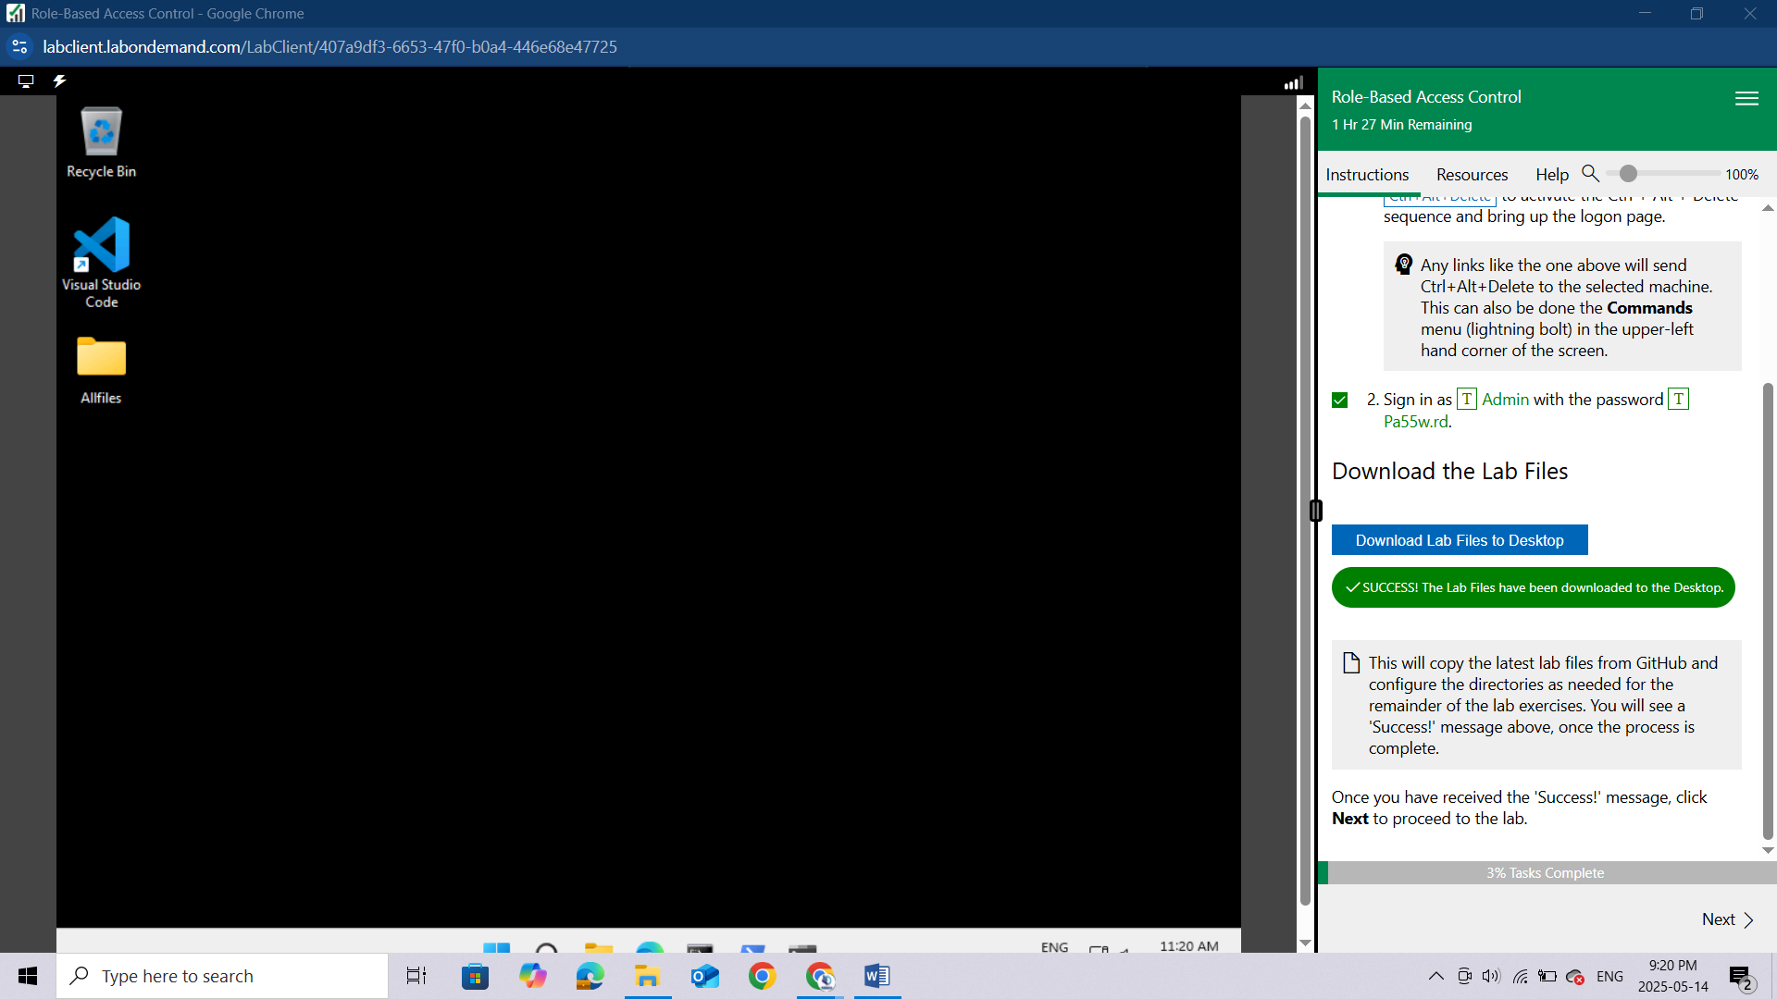

## Lab 01: Role-Based Access Control

### Lab scenario

You have been asked to create a proof of concept showing how Azure users and groups are created. Also, how role-based access control is used to assign roles to groups. Specifically, you need to:

Create a Senior Admins group containing the user account of Joseph Price as its member.

Create a Junior Admins group containing the user account of Isabel Garcia as its member.

Create a Service Desk group containing the user account of Dylan Williams as its member.

Assign the Virtual Machine Contributor role to the Service Desk group.

### Lab objectives

In this lab, you will complete the following exercises:

Exercise 1: Create the Senior Admins group with the user account Joseph Price as its member (the Azure portal).

Exercise 2: Create the Junior Admins group with the user account Isabel Garcia as its member (PowerShell).

Exercise 3: Create the Service Desk group with the user Dylan Williams as its member (Azure CLI).

Exercise 4: Assign the Virtual Machine Contributor role to the Service Desk group.

### Role-Based Access Control architecture diagram

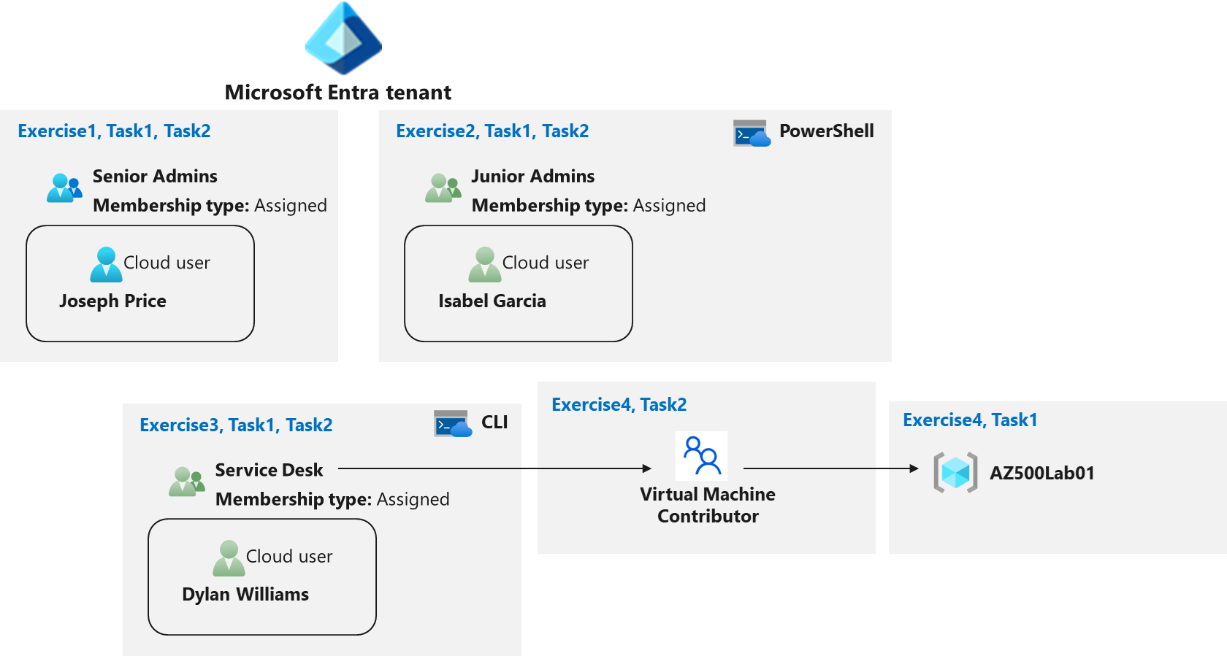

# Instructions

## Exercise 1: Create the Senior Admins group with the user account Joseph Price as its member

In this exercise, you will complete the following tasks:

Task 1: Use the Azure portal to create a user account for Joseph Price.

Task 2: Use the Azure portal to create a Senior Admins group and add the user account of Joseph Price to the group.

### Task 1: Use the Azure portal to create a user account for Joseph Price

In this task, you will create a user account for Joseph Price.

Start a browser session and **sign-in** to the Azure portal https://portal.azure.com/.

Sign in to the Azure portal using an account that has the Owner or Contributor role in the Azure subscription you are using for this lab and the Global Administrator role in the Microsoft Entra tenant associated with that subscription.

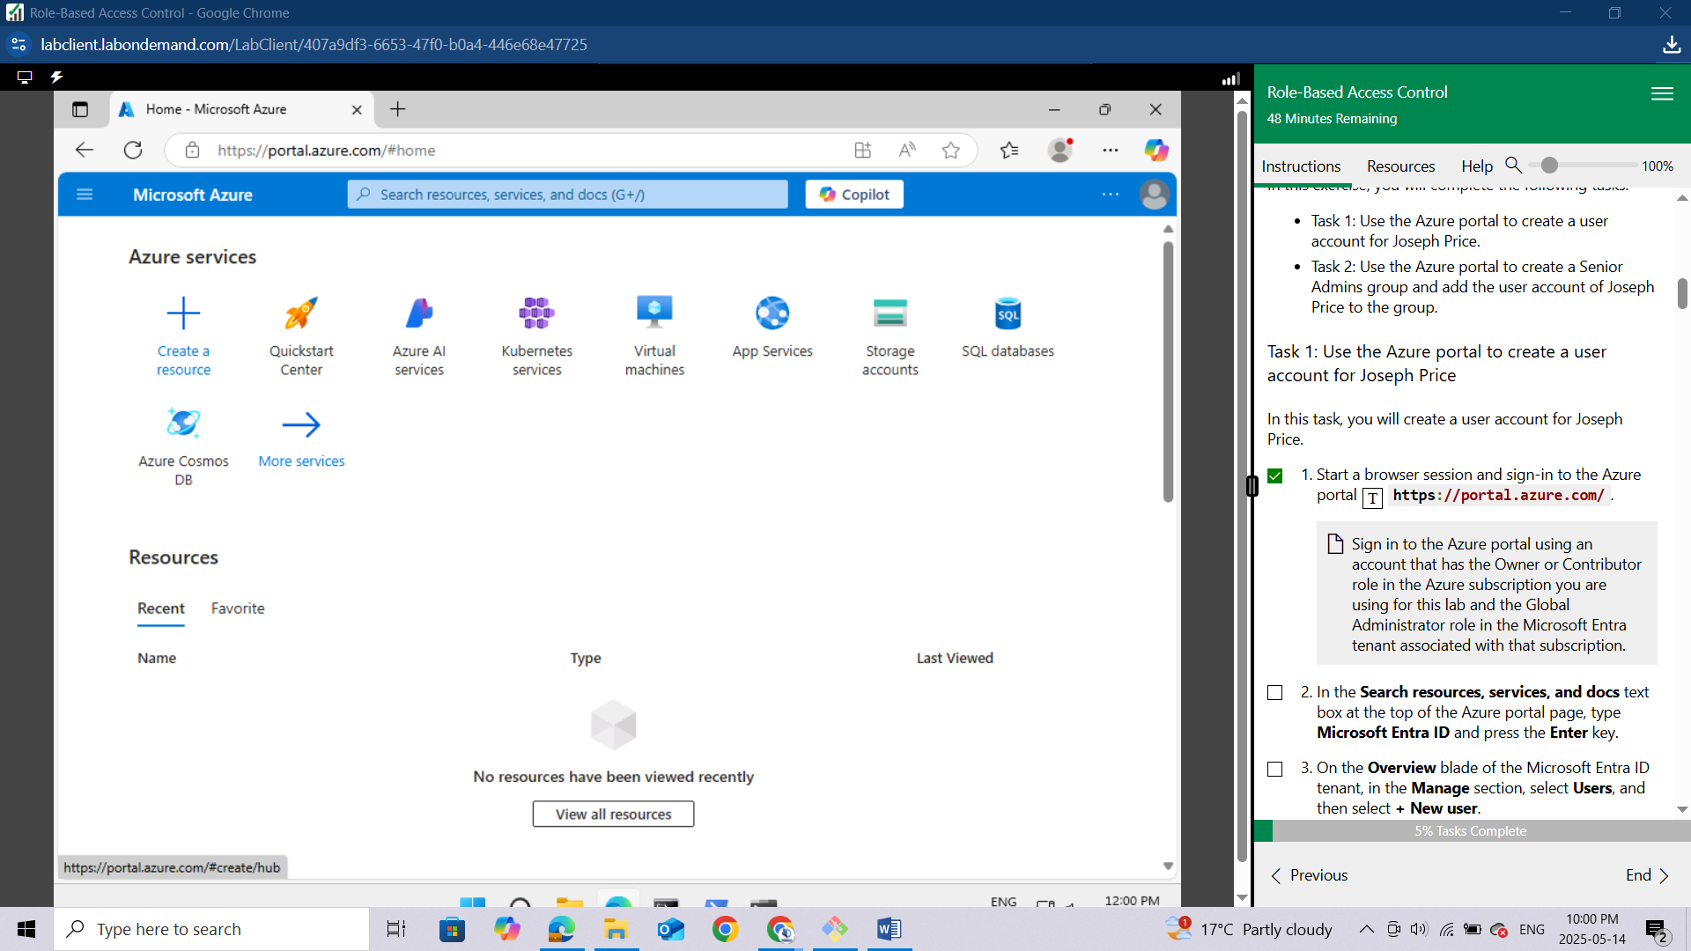

In the Search resources, services, and docs text box at the top of the Azure portal page, type **Microsoft Entra ID** and press the **Enter key.**

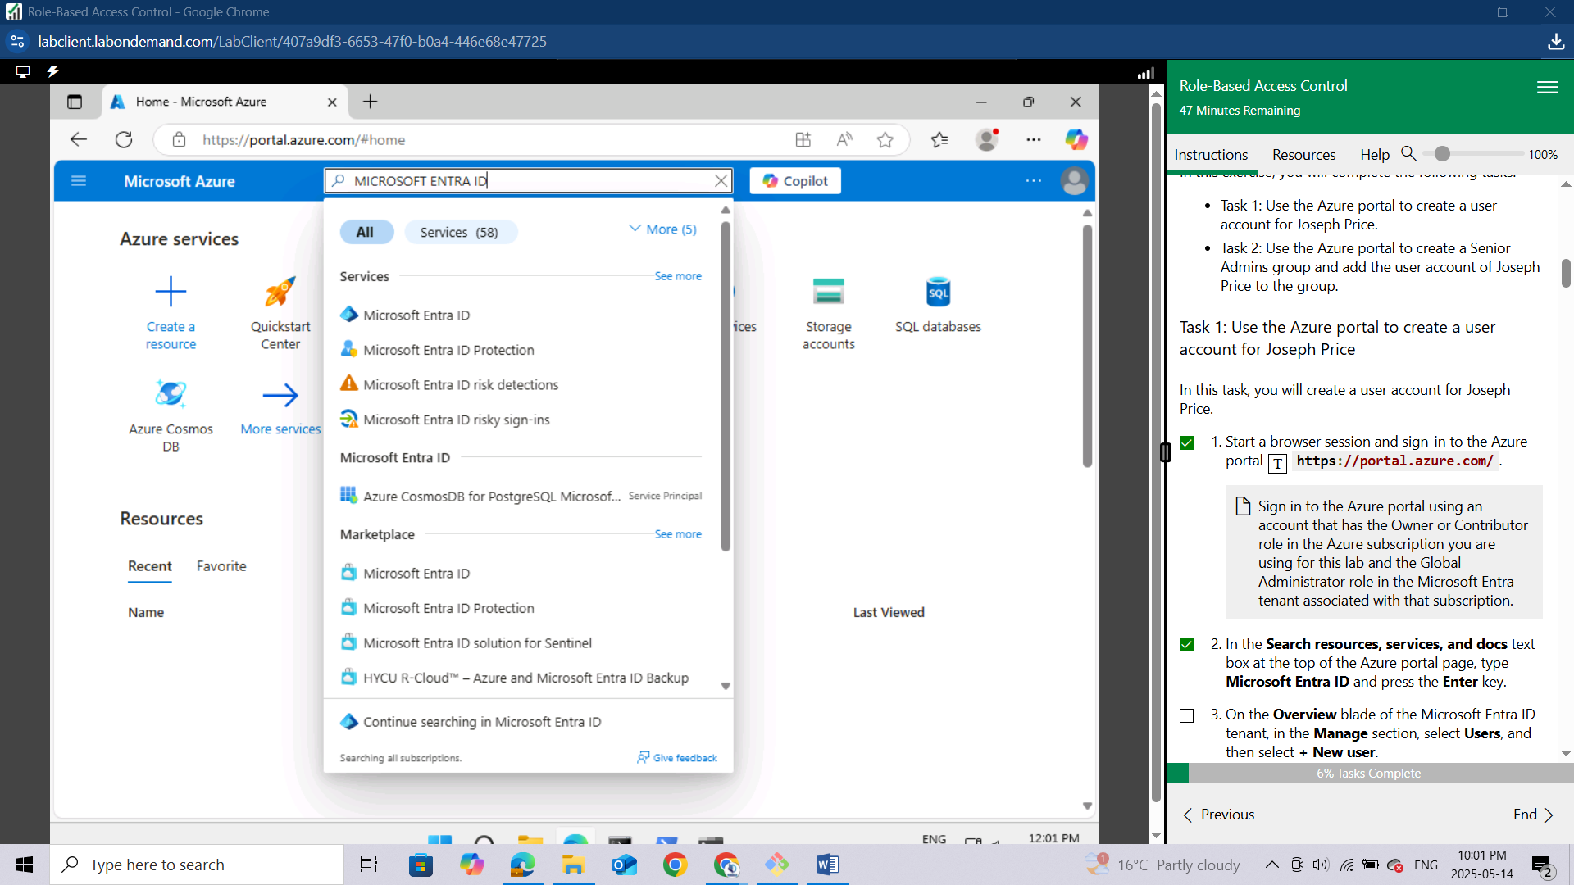

On the Overview blade of the Microsoft Entra ID tenant, in the **Manage** section, **select Users**, and then select **+ New user**.

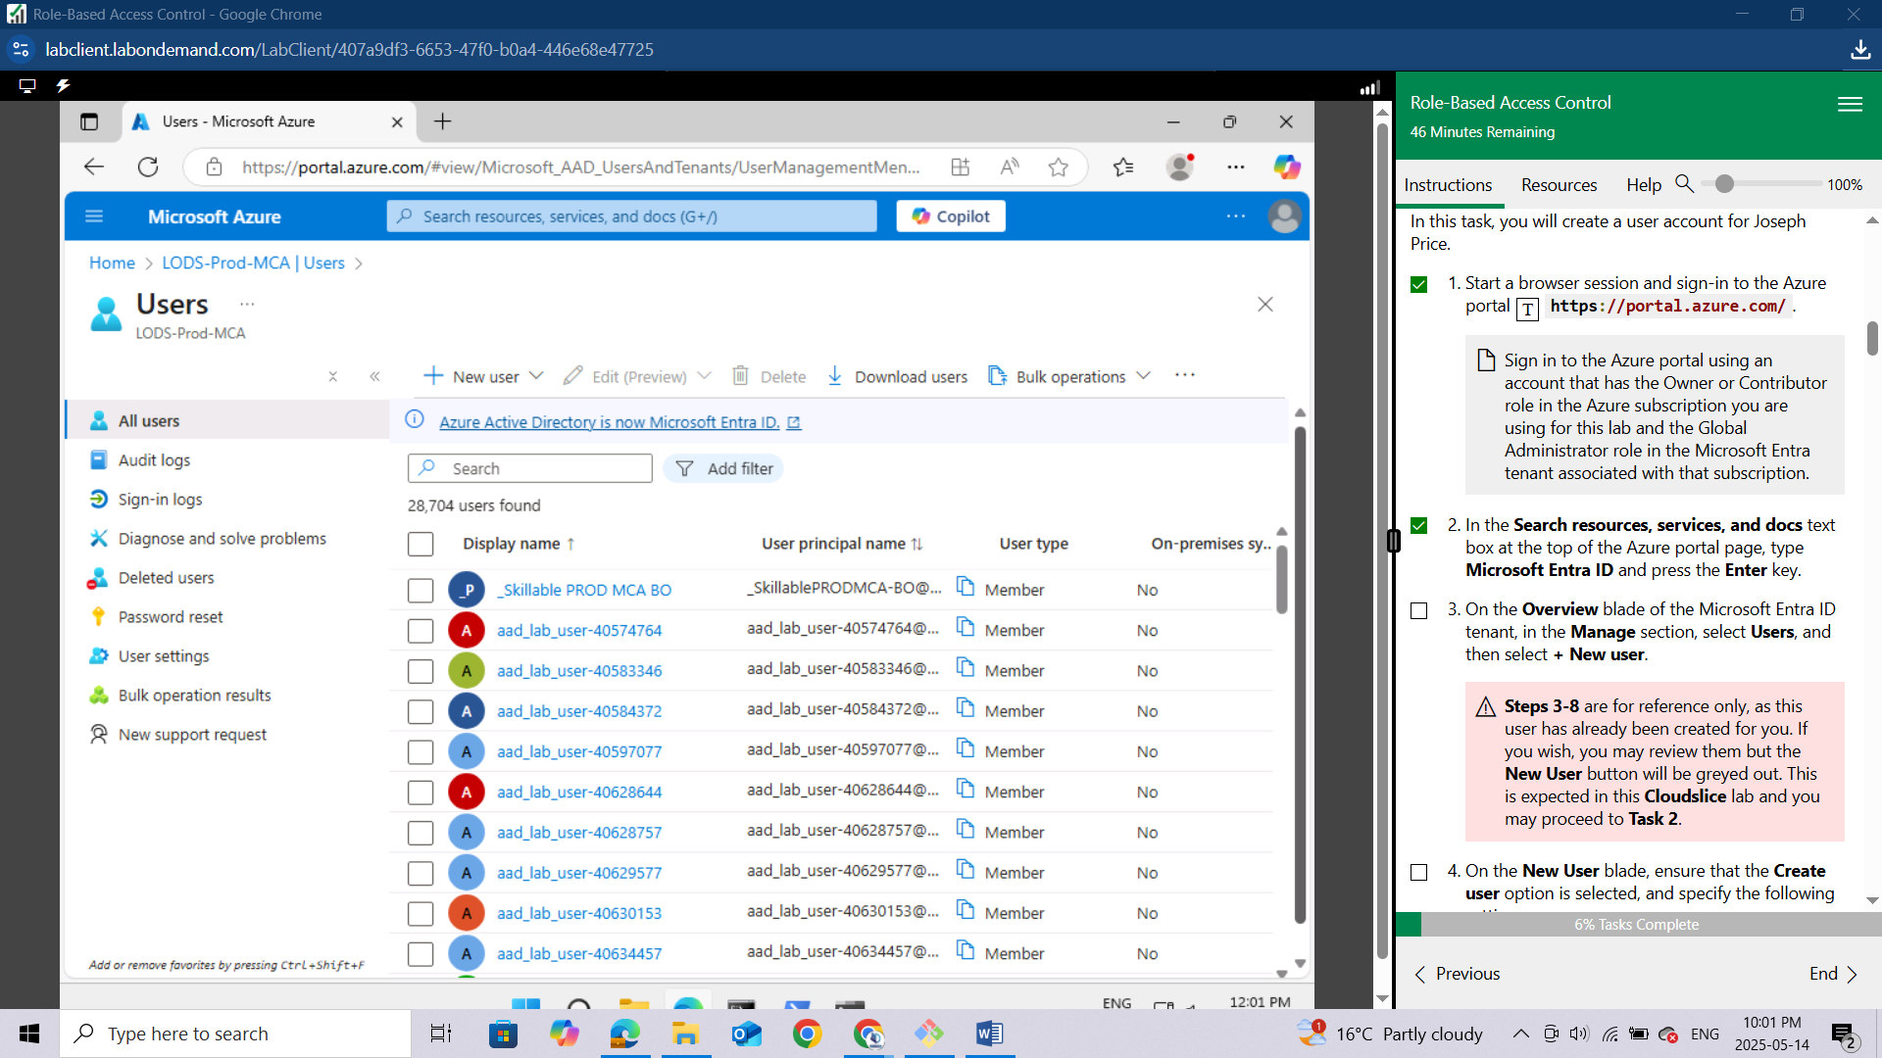

*Steps 3-8 are for reference only, as this user has already been created for you. If you wish, you may review them but the New User button will be greyed out. This is expected in this Cloudslice lab and you may proceed to Task 2.*

On the New User blade, ensure that the Create user option is selected, and specify the following settings:

**Setting** **Value**

**User name** Joseph

**Name** Joseph Price

Click on the copy icon next to the User name to copy the full user.

Ensure that the Auto-generate password is selected, select the Show password checkbox to identify the automatically generated password. You would need to provide this password, along with the user name to Joseph.

Click **Create**.

Refresh the **Users | All users** blade to verify the new user was created in your Microsoft Entra tenant.

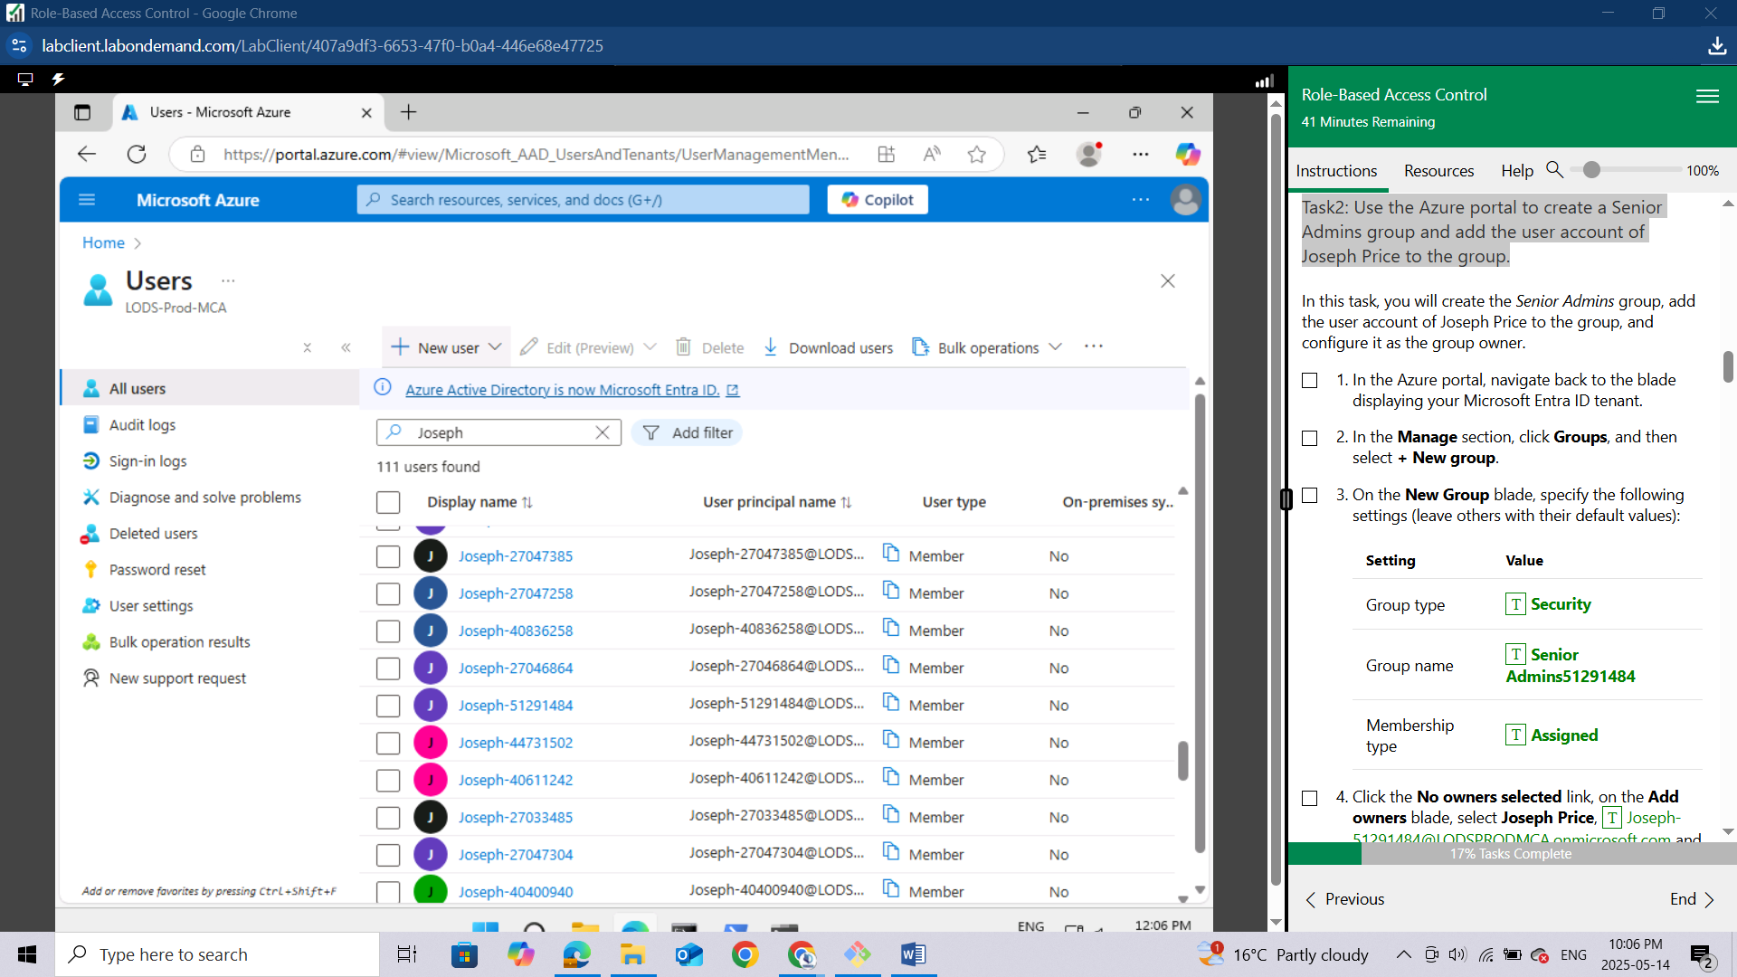

### Task2: Use the Azure portal to create a Senior Admins group and add the user account of Joseph Price to the group.

In the Azure portal, navigate back to the blade displaying your **Microsoft Entra ID tenant.**

In the **Manage** section, click **Groups**, and then select **+ New group.**

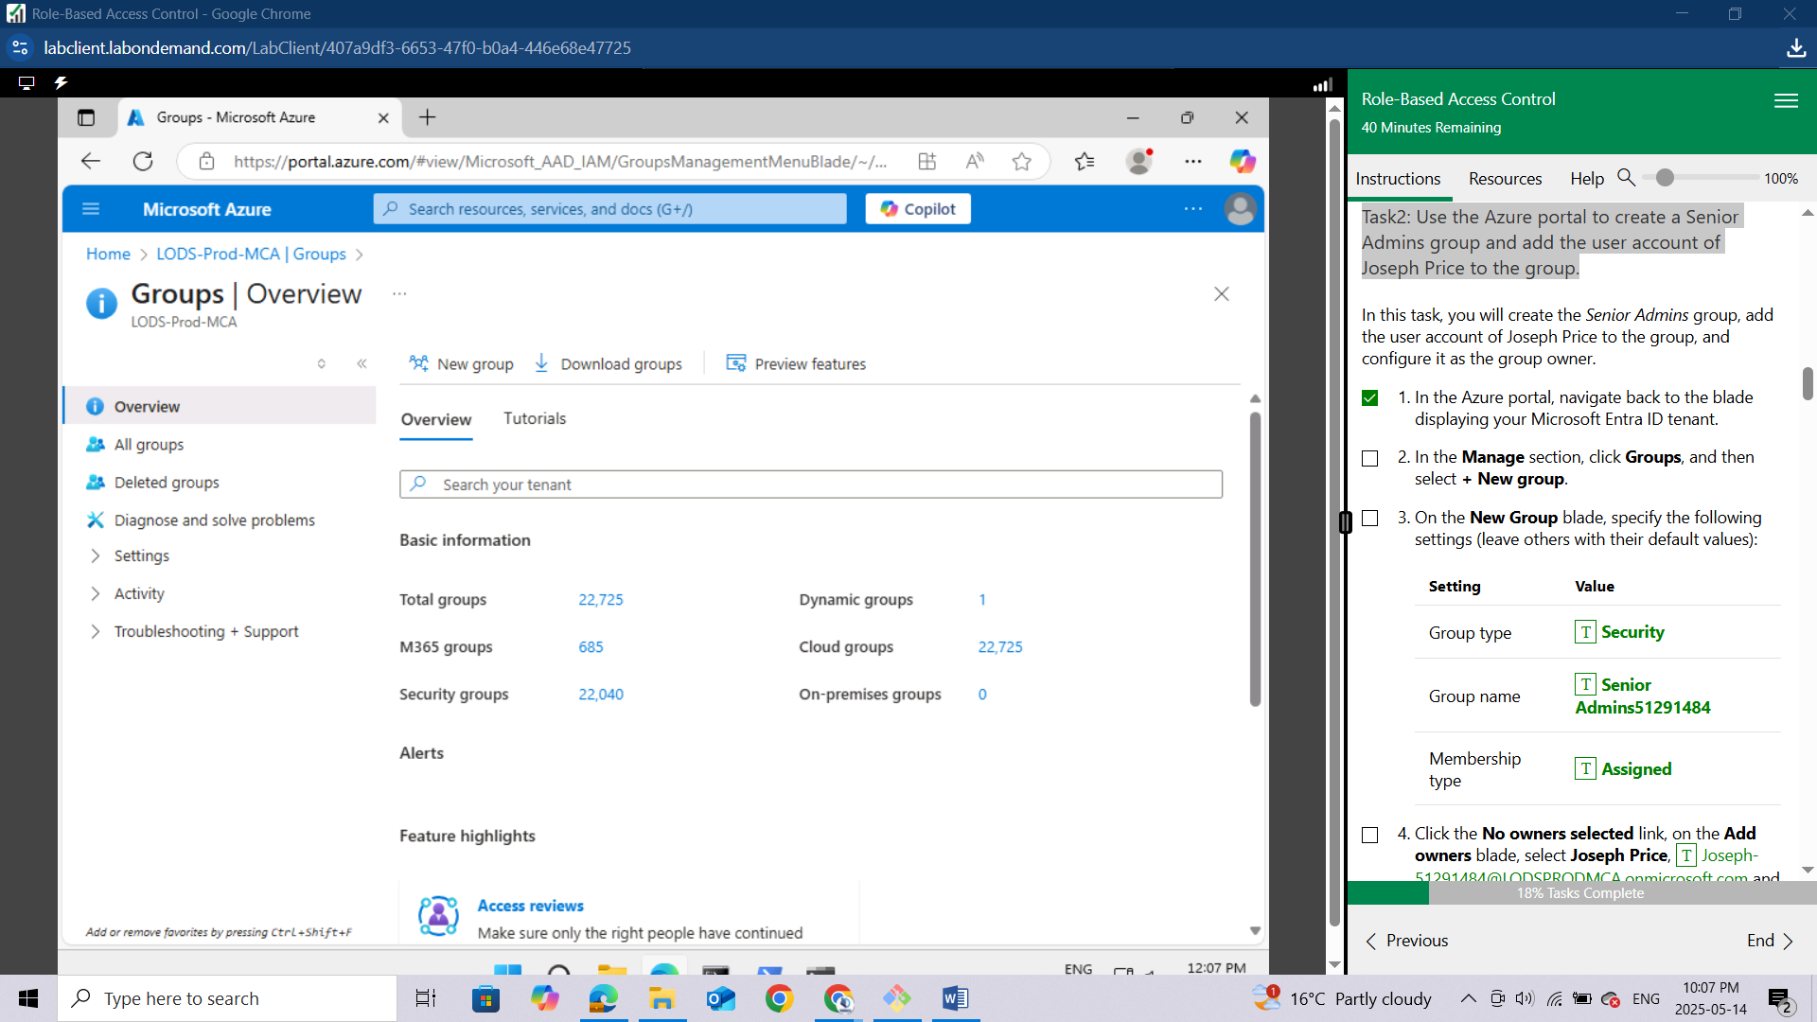

On the New Group blade, specify the following settings (leave others with their default values):

**Setting** Value

**Group type** Security

**Group name** Senior Admins51291484

**Membership type** Assigned

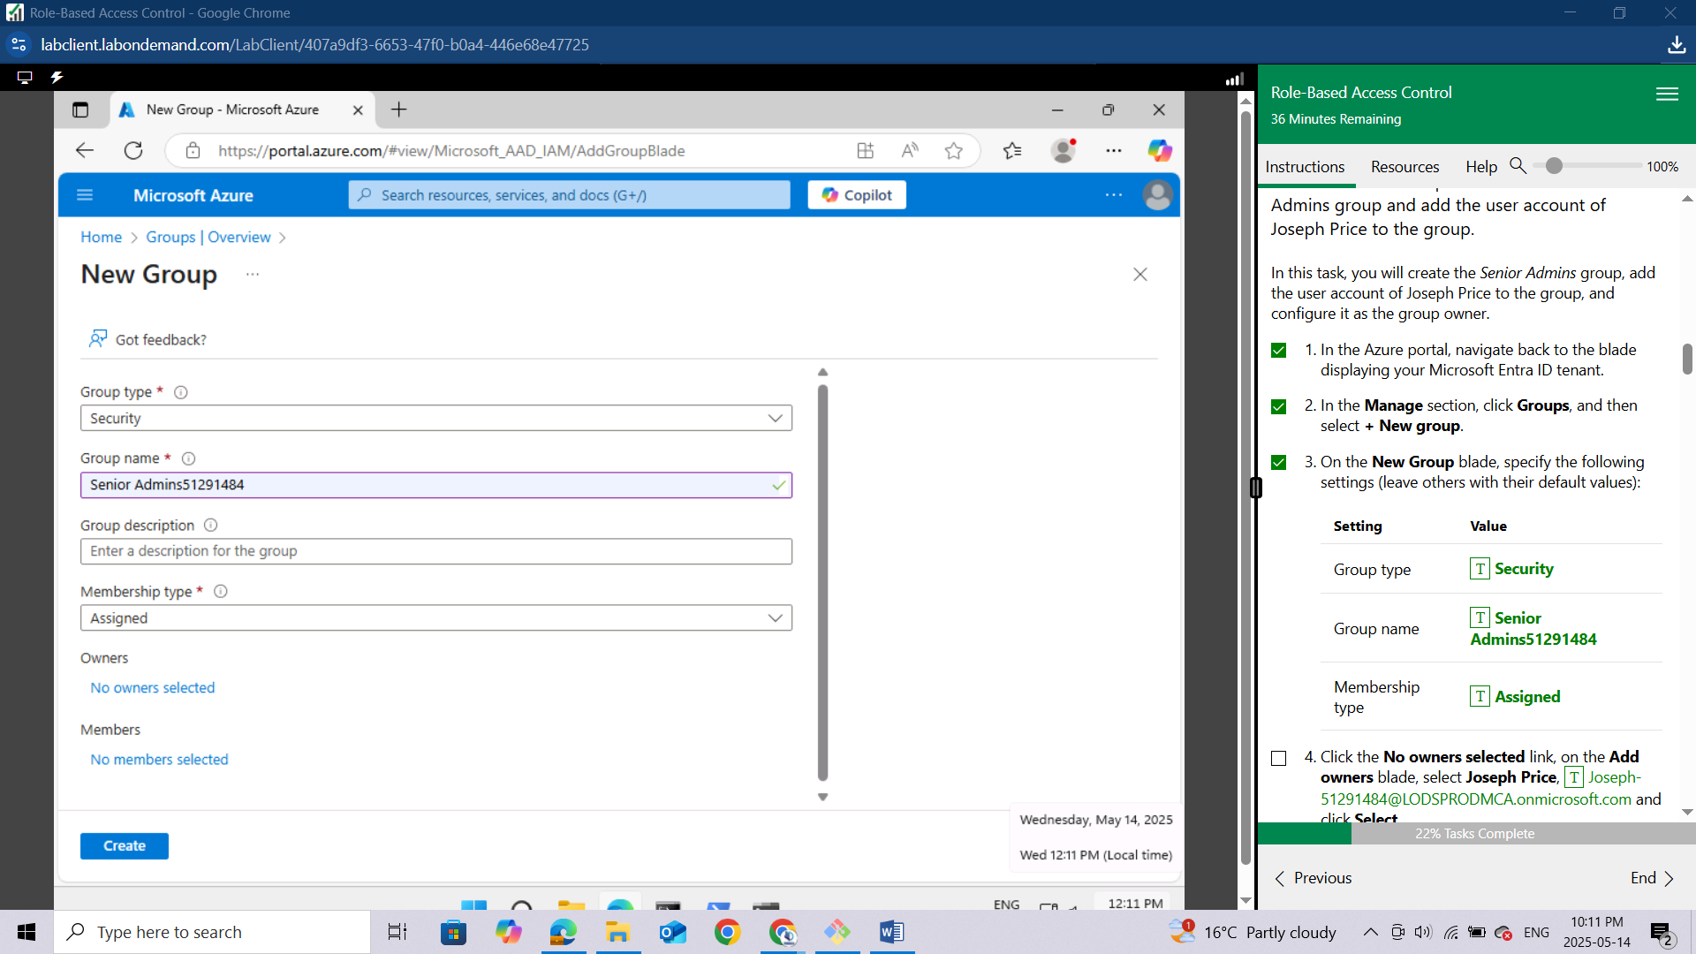

Click the ***No owners selected link***, on the **Add owners** blade, select **Joseph Price**, **Joseph-51291484@LODSPRODMCA.onmicrosoft.com** and click **Select**.

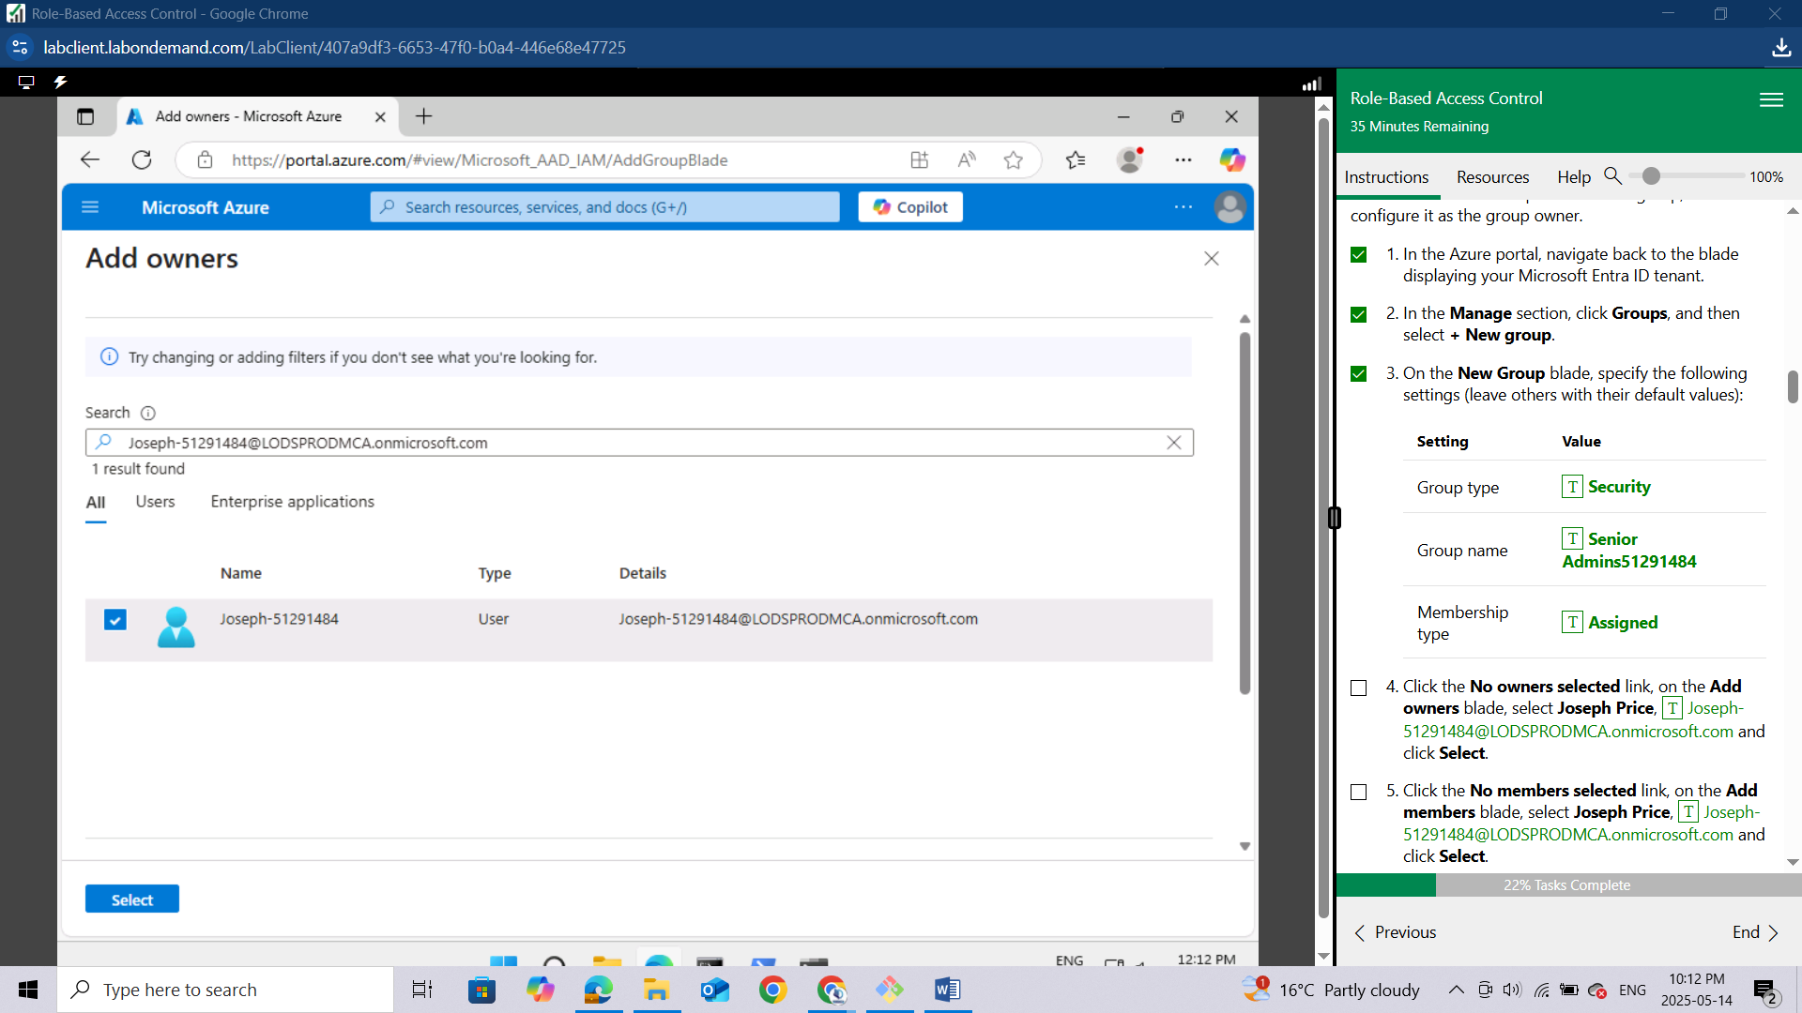

Click the ***No members selected link***, on the **Add members** blade, select **Joseph Price, Joseph-51291484@LODSPRODMCA.onmicrosoft.com** and click **Select**.

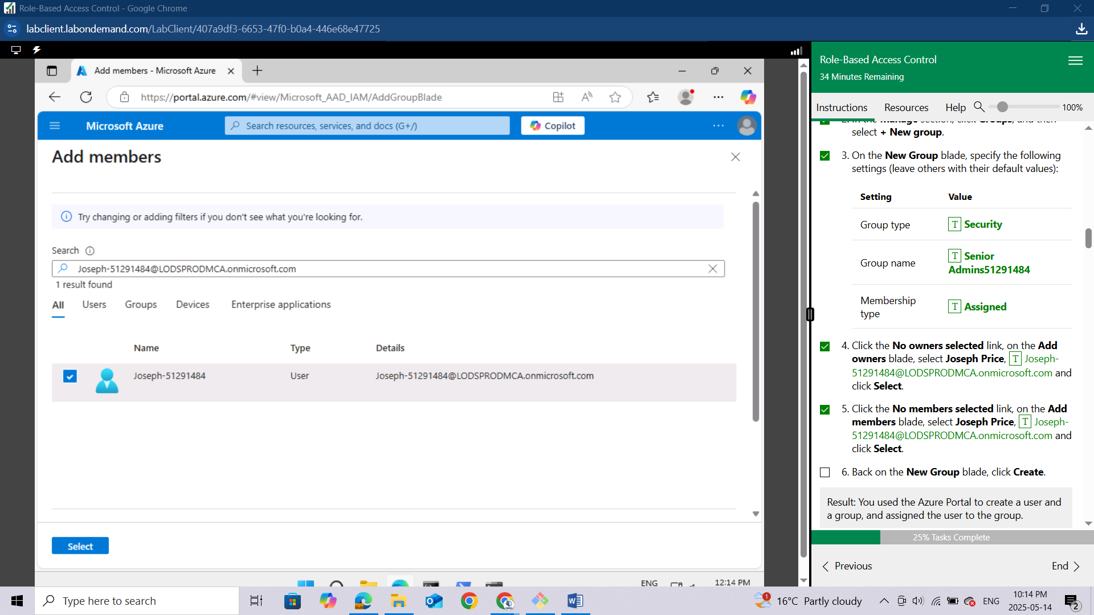

Back on the **New Group** blade, click **Create**.

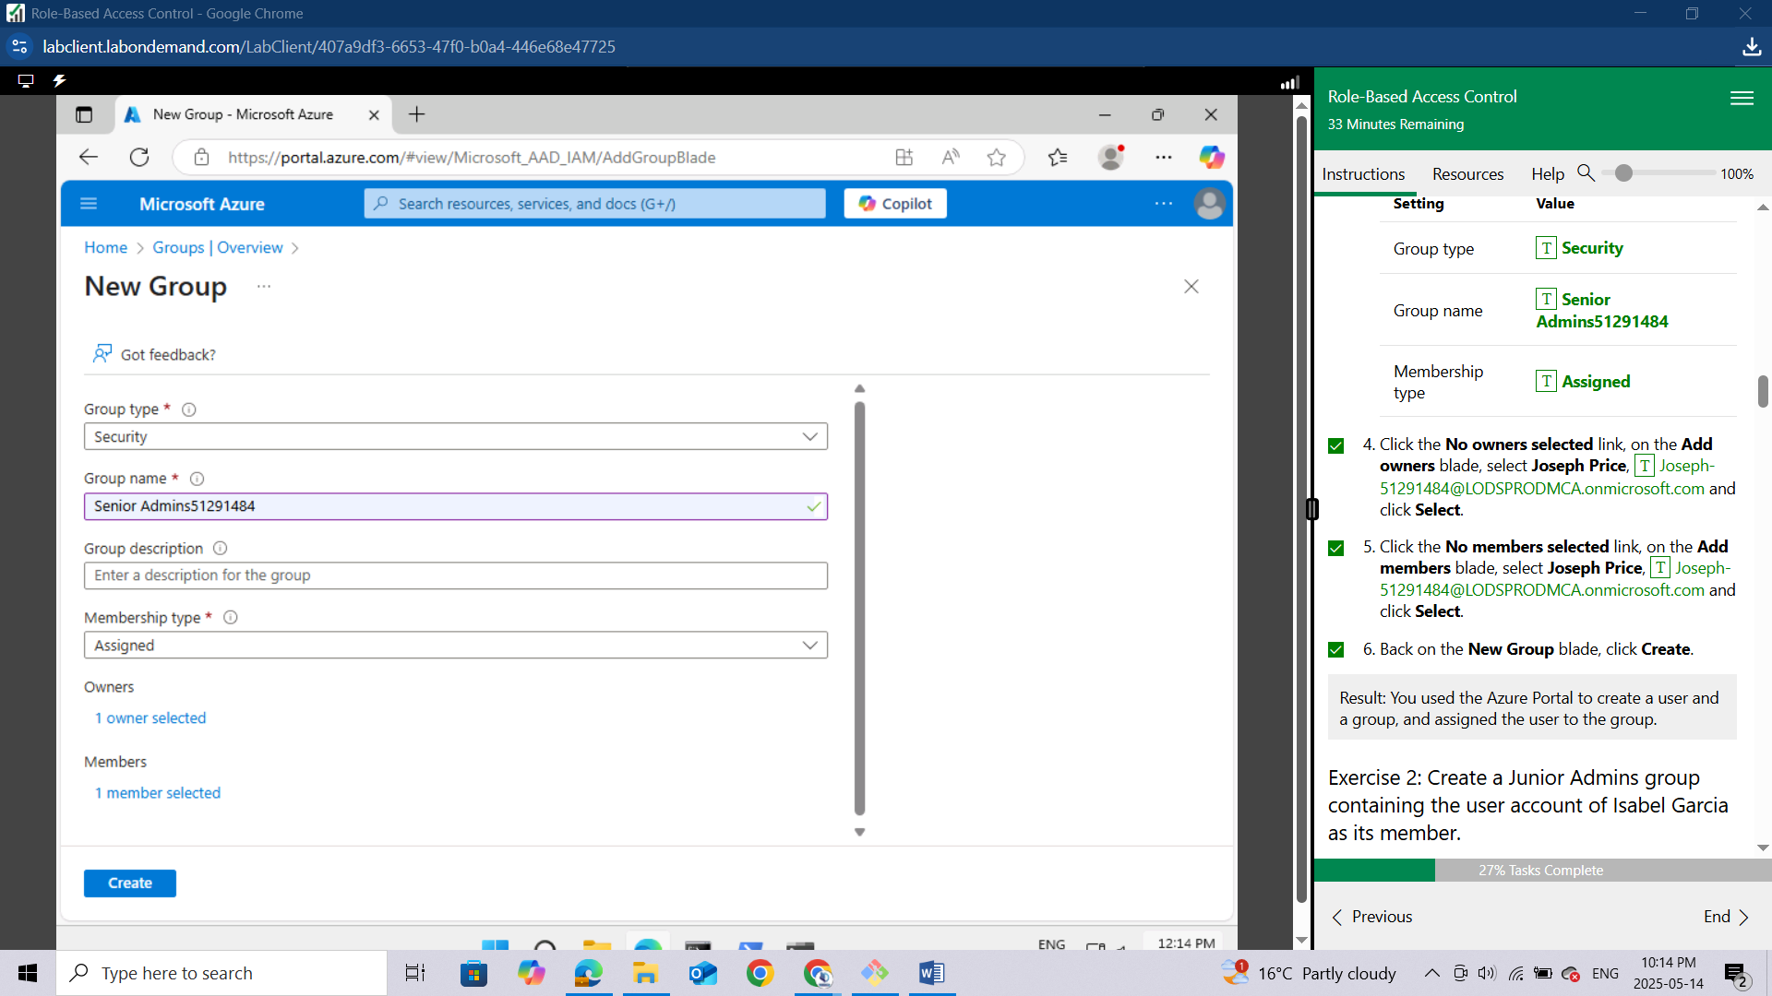

***Result: You used the Azure Portal to create a user and a group, and assigned the user to the group.***

## Exercise 2: Create a Junior Admins group containing the user account of Isabel Garcia as its member.

In this exercise, you will complete the following tasks:

Task 1: Use PowerShell to create a user account for Isabel Garcia.

Task 2: Use PowerShell to create the Junior Admins group and add the user account of Isabel Garcia to the group.

### Task 1: Use PowerShell to create a user account for Isabel Garcia.

In this task, you will create a user account for Isabel Garcia by using PowerShell.

Open the Cloud Shell by clicking the first icon in the top right of the Azure Portal. If prompted, select PowerShell and Create storage.

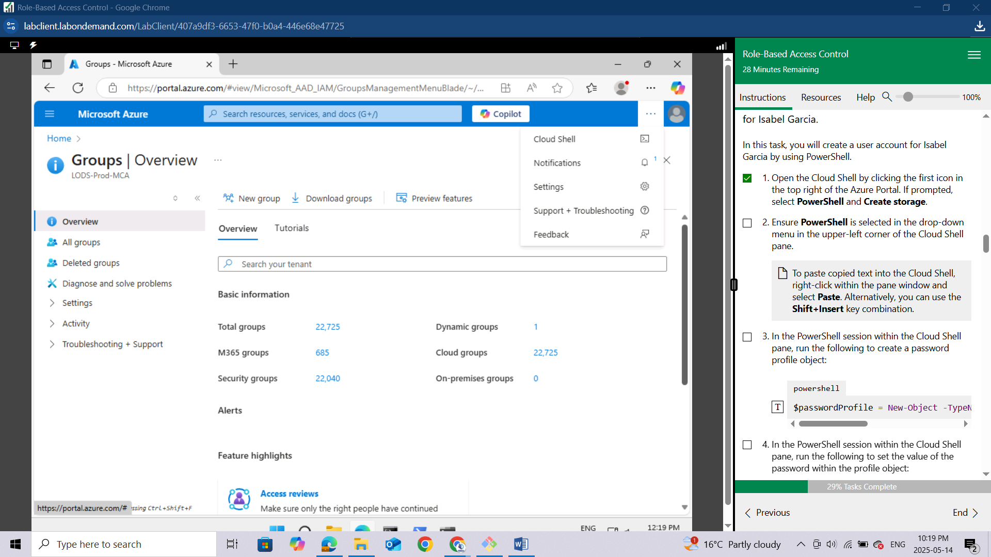

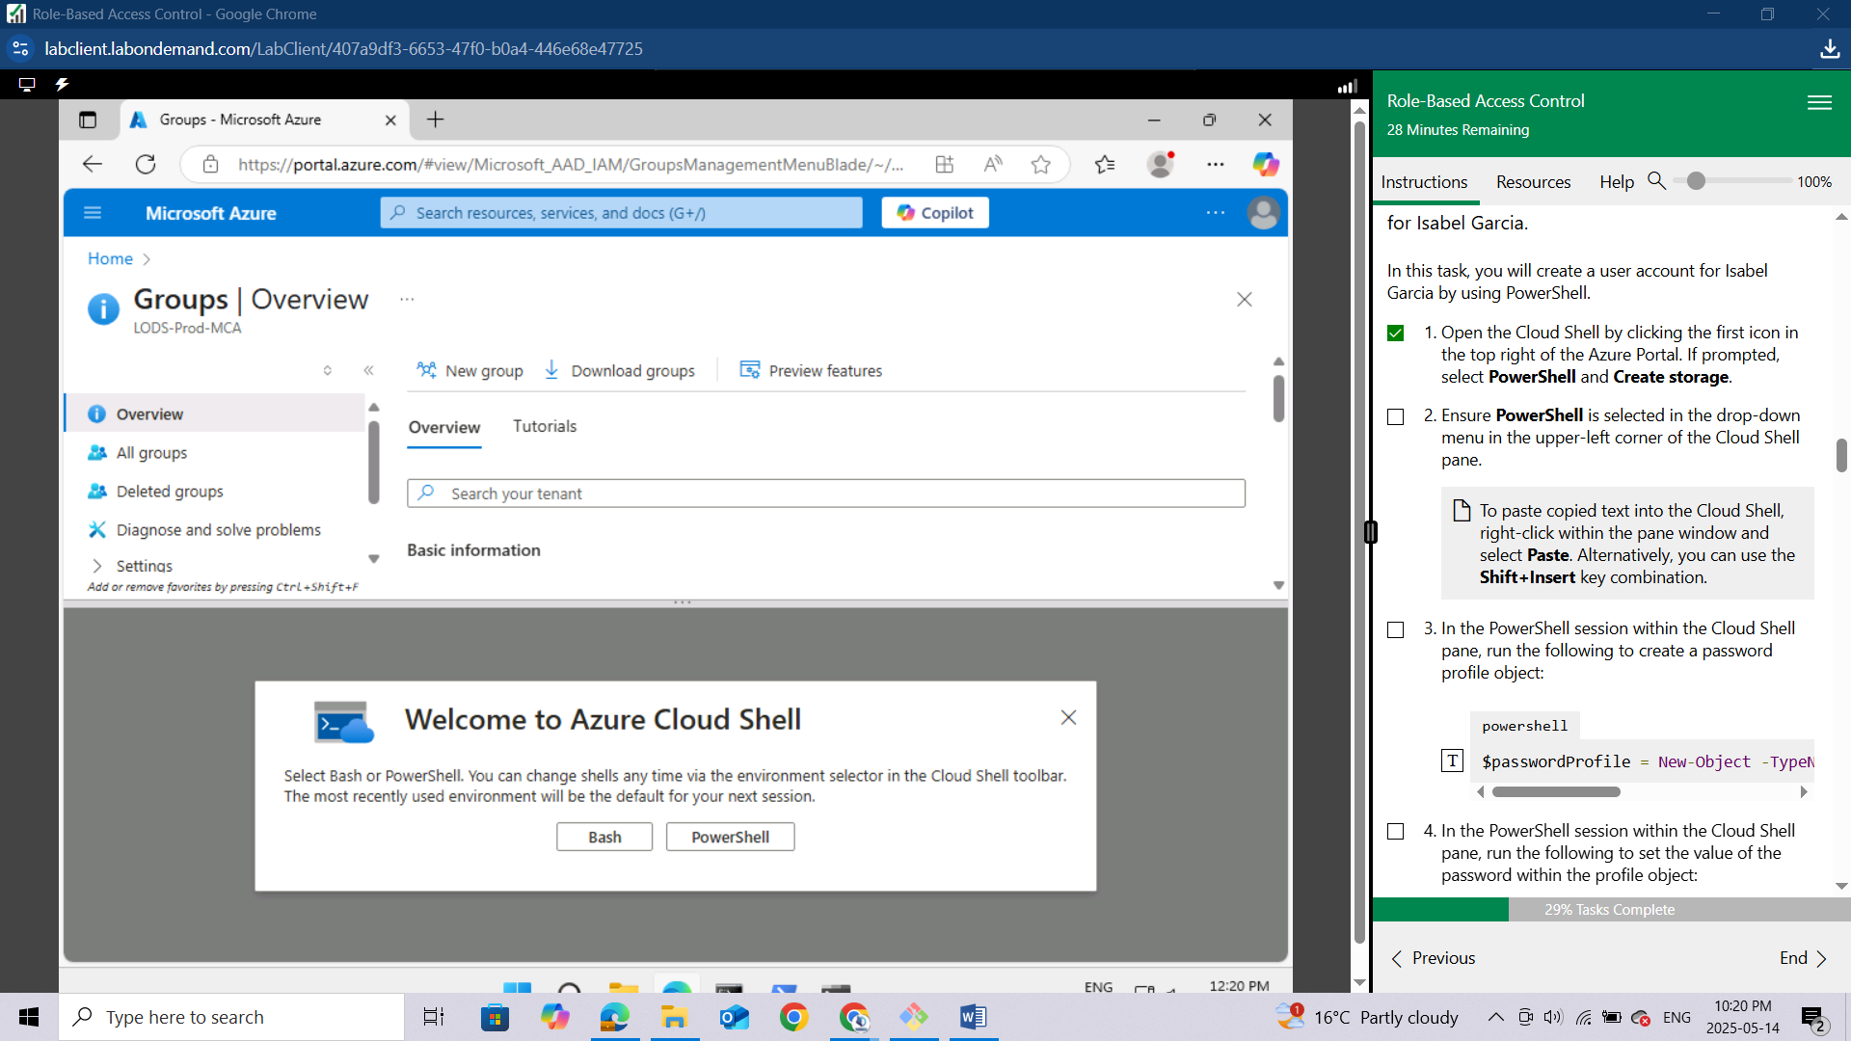

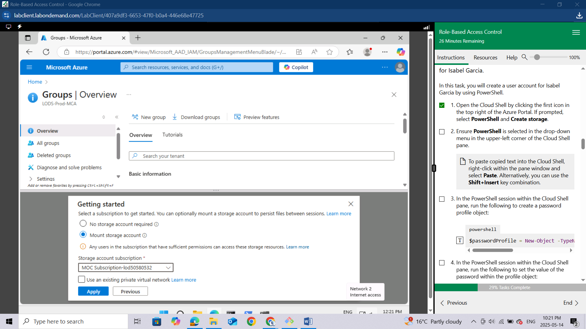

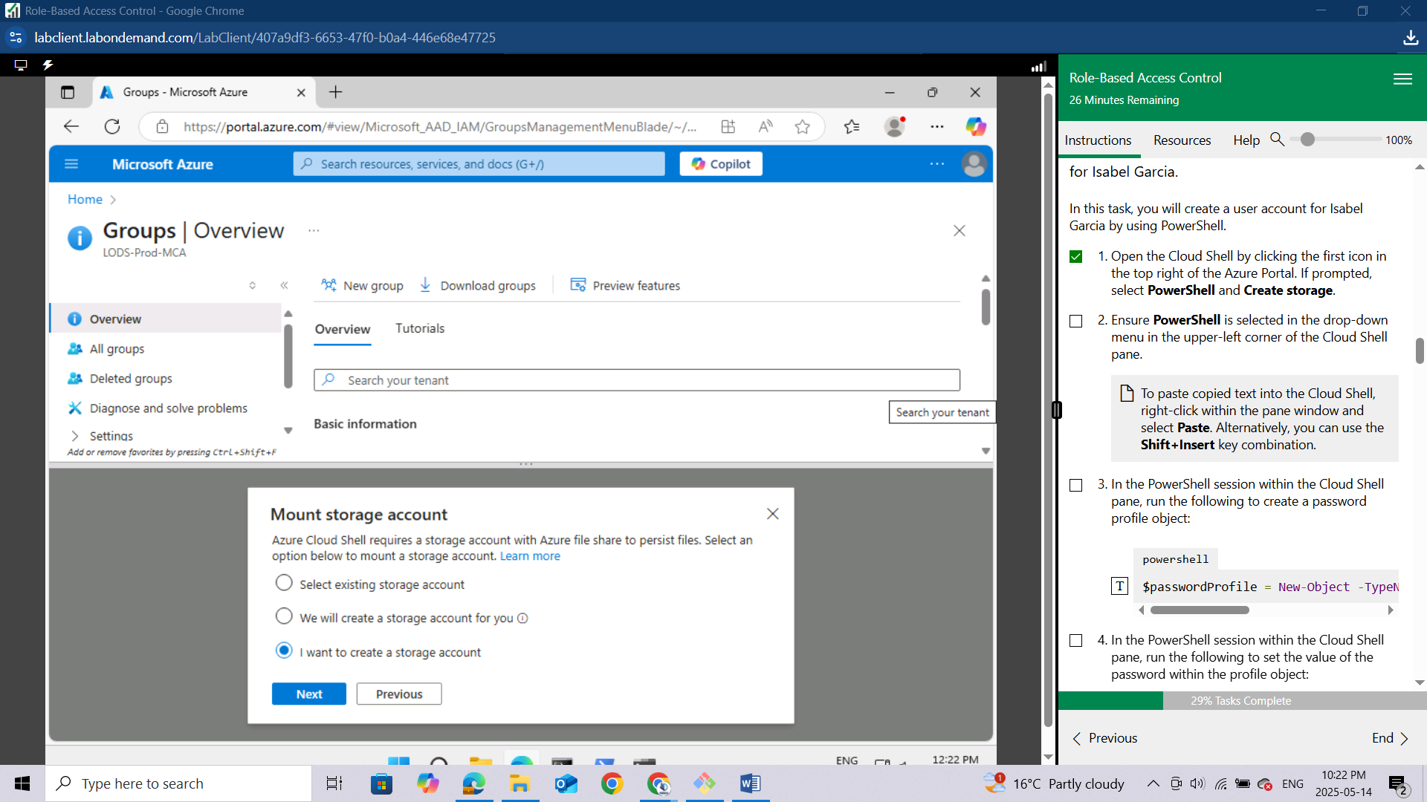

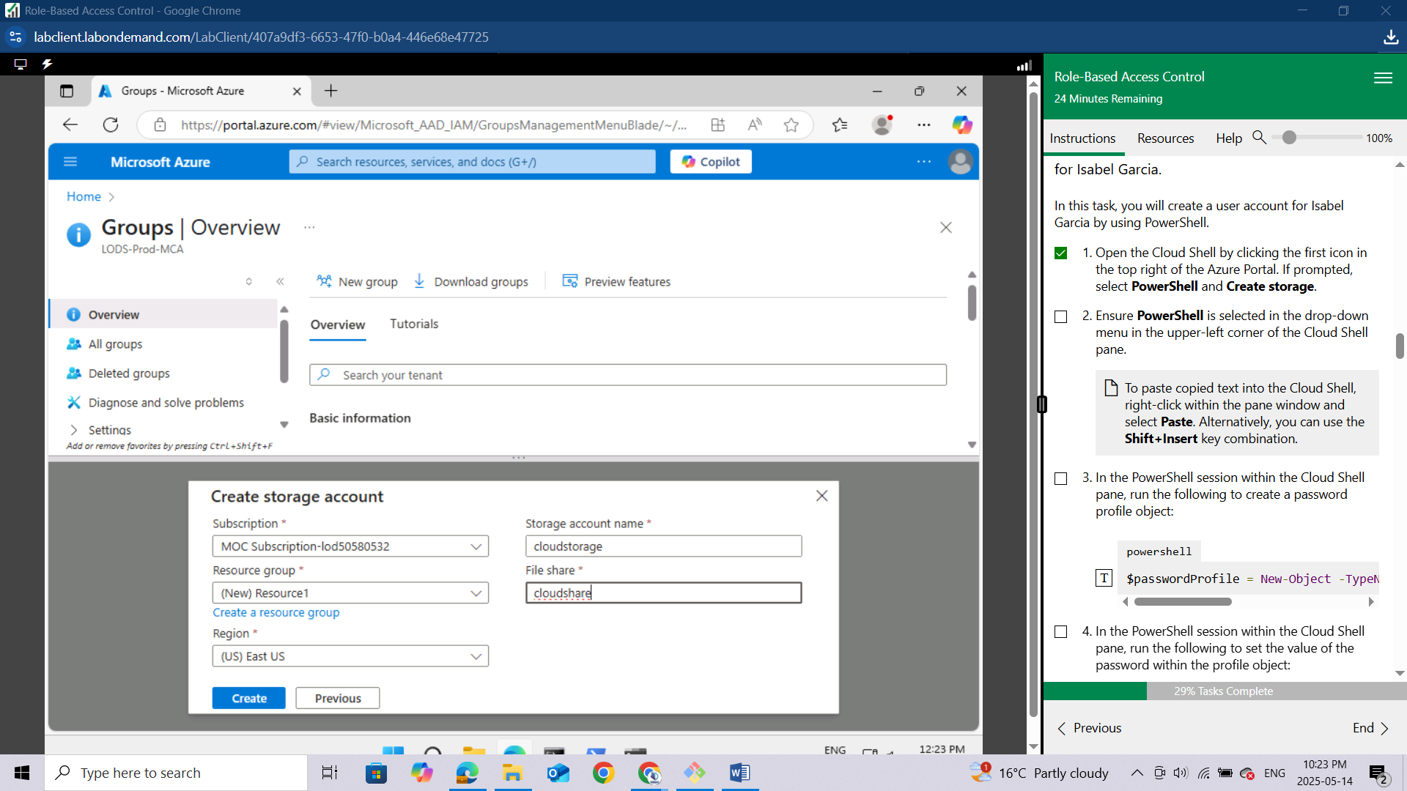

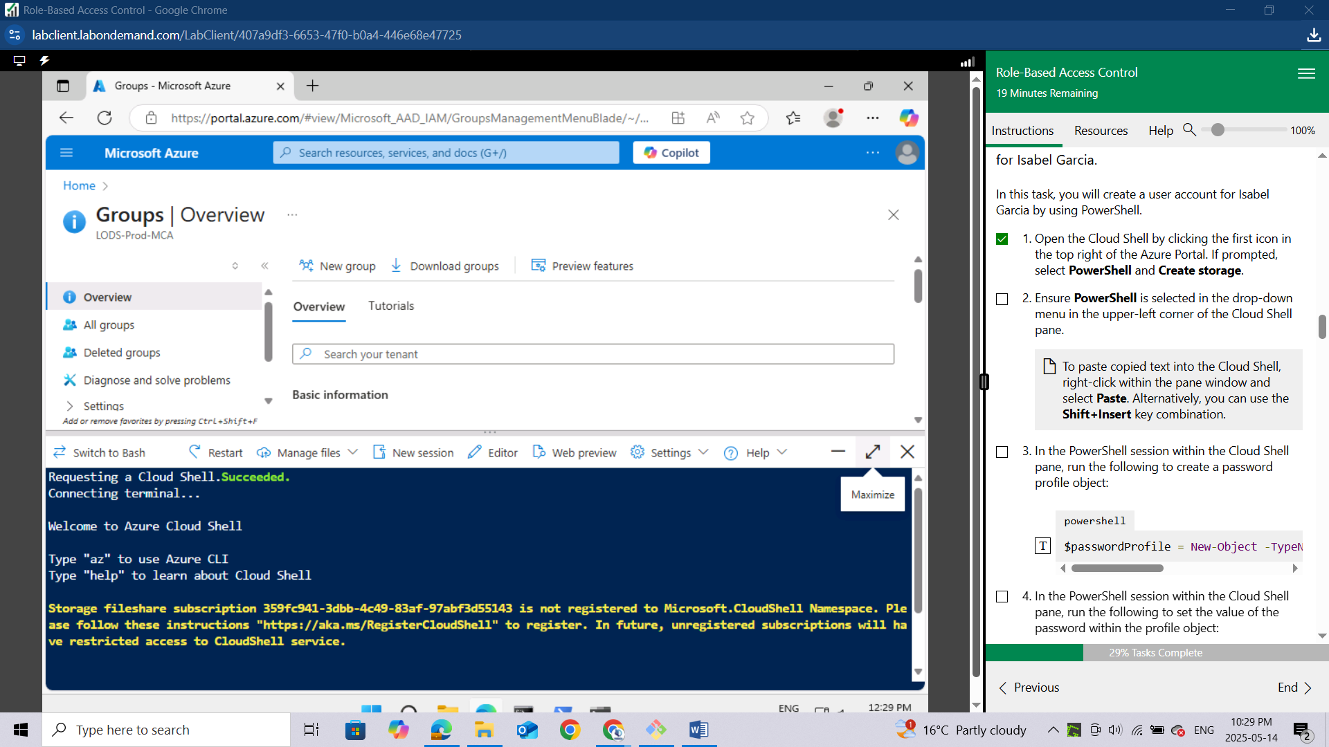

Ensure PowerShell is selected in the drop-down menu in the upper-left corner of the Cloud Shell pane.

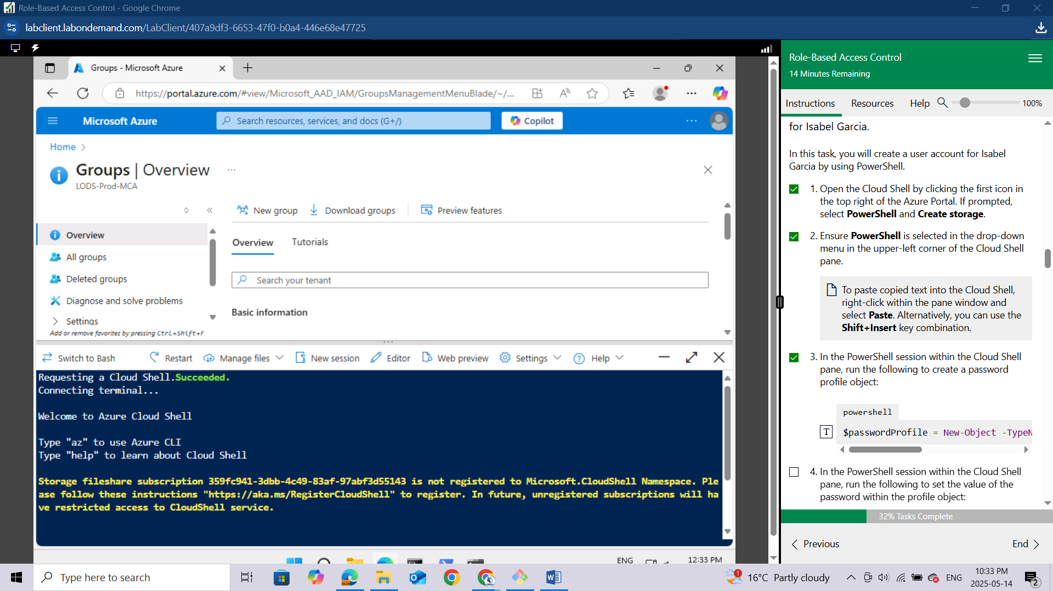

*To paste copied text into the Cloud Shell,* ***right-click*** *within the pane window and select* ***Paste****. Alternatively, you can use the* ***Shift+Insert*** *key combination.*

In the PowerShell session within the Cloud Shell pane, run the following to create a password profile object:

**powershell**

$passwordProfile.Password = "Pa55w.rd1234"

In the PowerShell session within the Cloud Shell pane, run the following to set the value of the password within the profile object:

**powershell**

$passwordProfile.Password = "Pa55w.rd1234"

In the PowerShell session within the Cloud Shell pane, run the following to connect to Microsoft Entra ID:

**powershell**

Connect-AzureAD

In the PowerShell session within the Cloud Shell pane, run the following to identify the name of your Microsoft Entra tenant:

**powershell**

$domainName = ((Get-AzureAdTenantDetail).VerifiedDomains)[0].Name

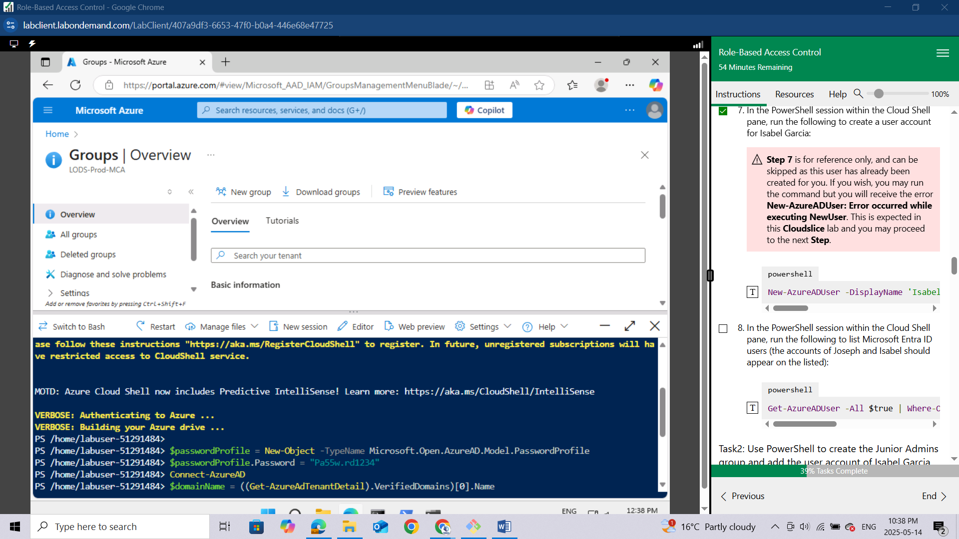

In the PowerShell session within the Cloud Shell pane, run the following to create a user account for Isabel Garcia:

*Step 7 is for reference only, and can be skipped as this user has already been created for you. If you wish, you may run the command but you will receive the error New-AzureADUser: Error occurred while executing NewUser. This is expected in this Cloudslice lab and you may proceed to the next Step.*

**powershell**

New-AzureADUser -DisplayName 'Isabel Garcia' -PasswordProfile $passwordProfile -UserPrincipalName "Isabel@$domainName" -AccountEnabled $true -MailNickName 'Isabel'

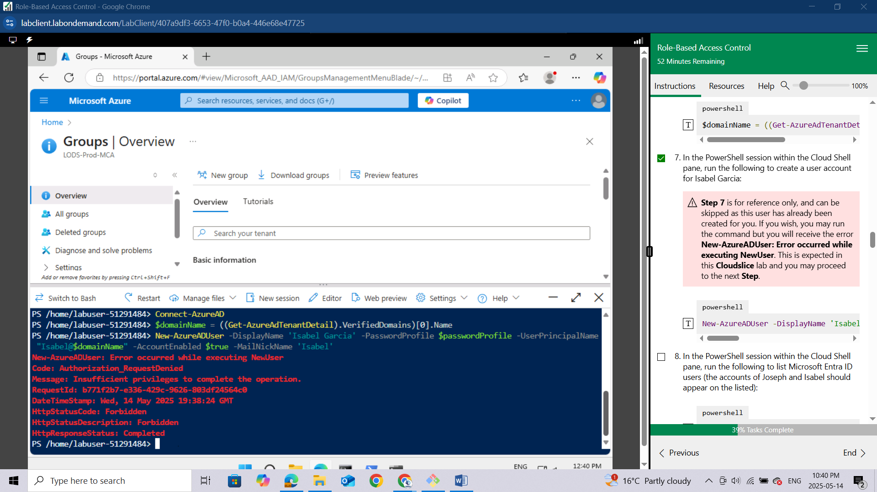

In the PowerShell session within the Cloud Shell pane, run the following to list Microsoft Entra ID users (the accounts of Joseph and Isabel should appear on the listed):

**powershell**

1. Get-AzureADUser -All $true | Where-Object {$_.UserPrincipalName -like "*51291484@LOD*"}

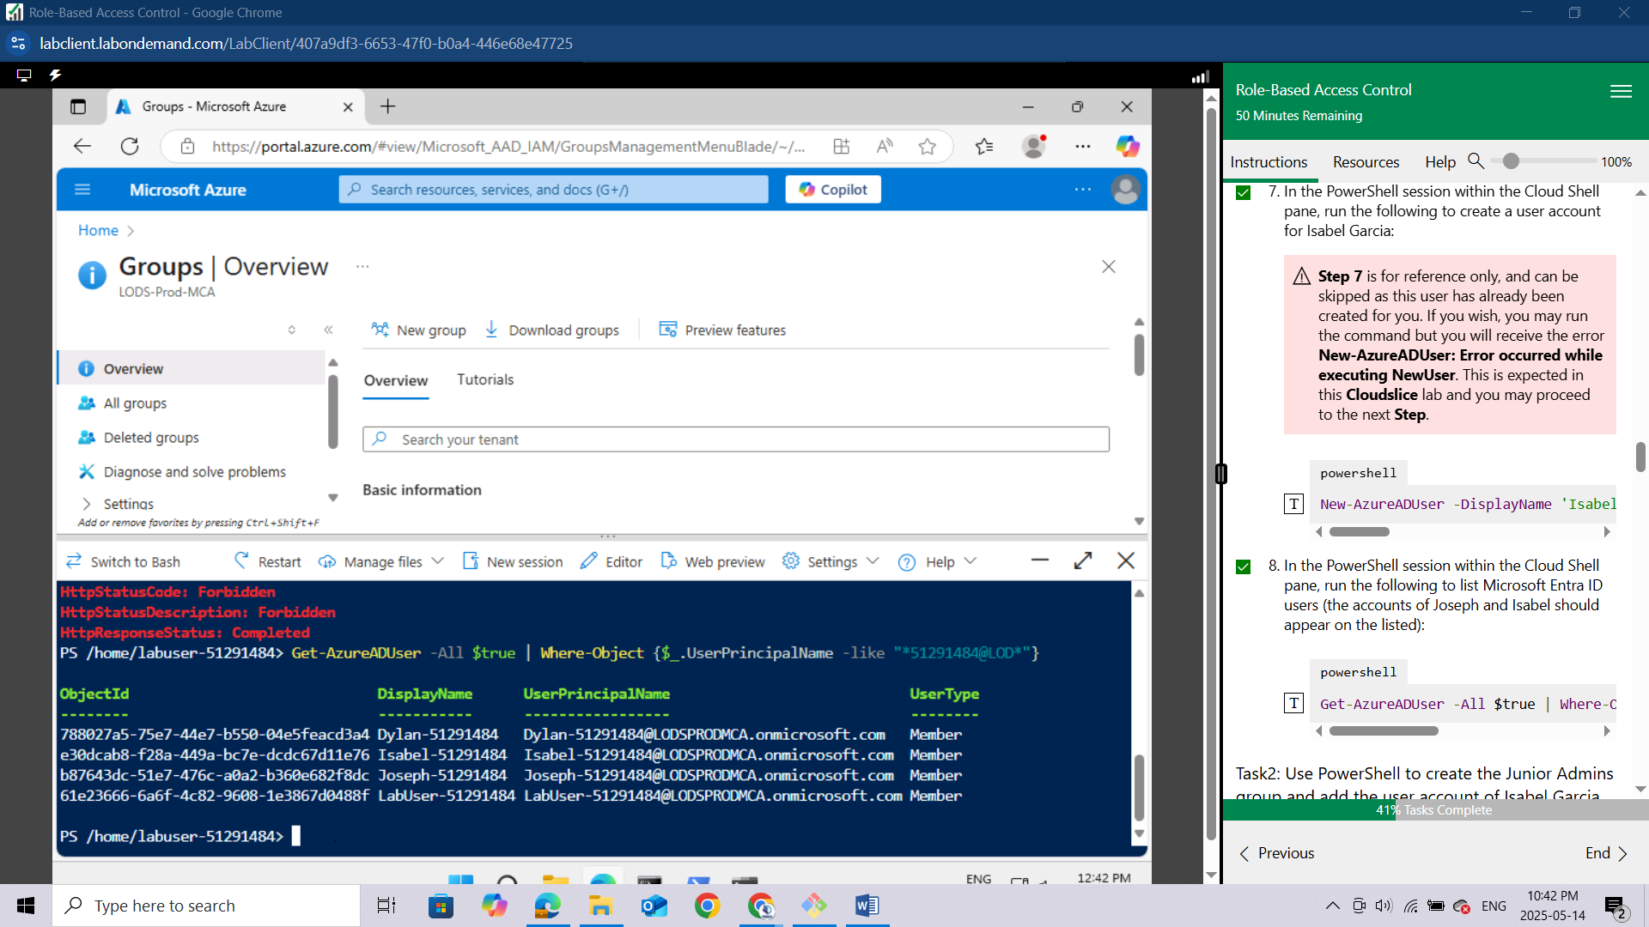

### Task2: Use PowerShell to create the Junior Admins group and add the user account of Isabel Garcia to the group.

In this task, you will create the Junior Admins group and add the user account of Isabel Garcia to the group by using PowerShell.

In the same PowerShell session within the Cloud Shell pane, run the following to create a new security group named Junior Admins:

**Powershell**

New-AzureADGroup -DisplayName 'Junior Admins51291484' -MailEnabled $false -SecurityEnabled $true -MailNickName JuniorAdmins

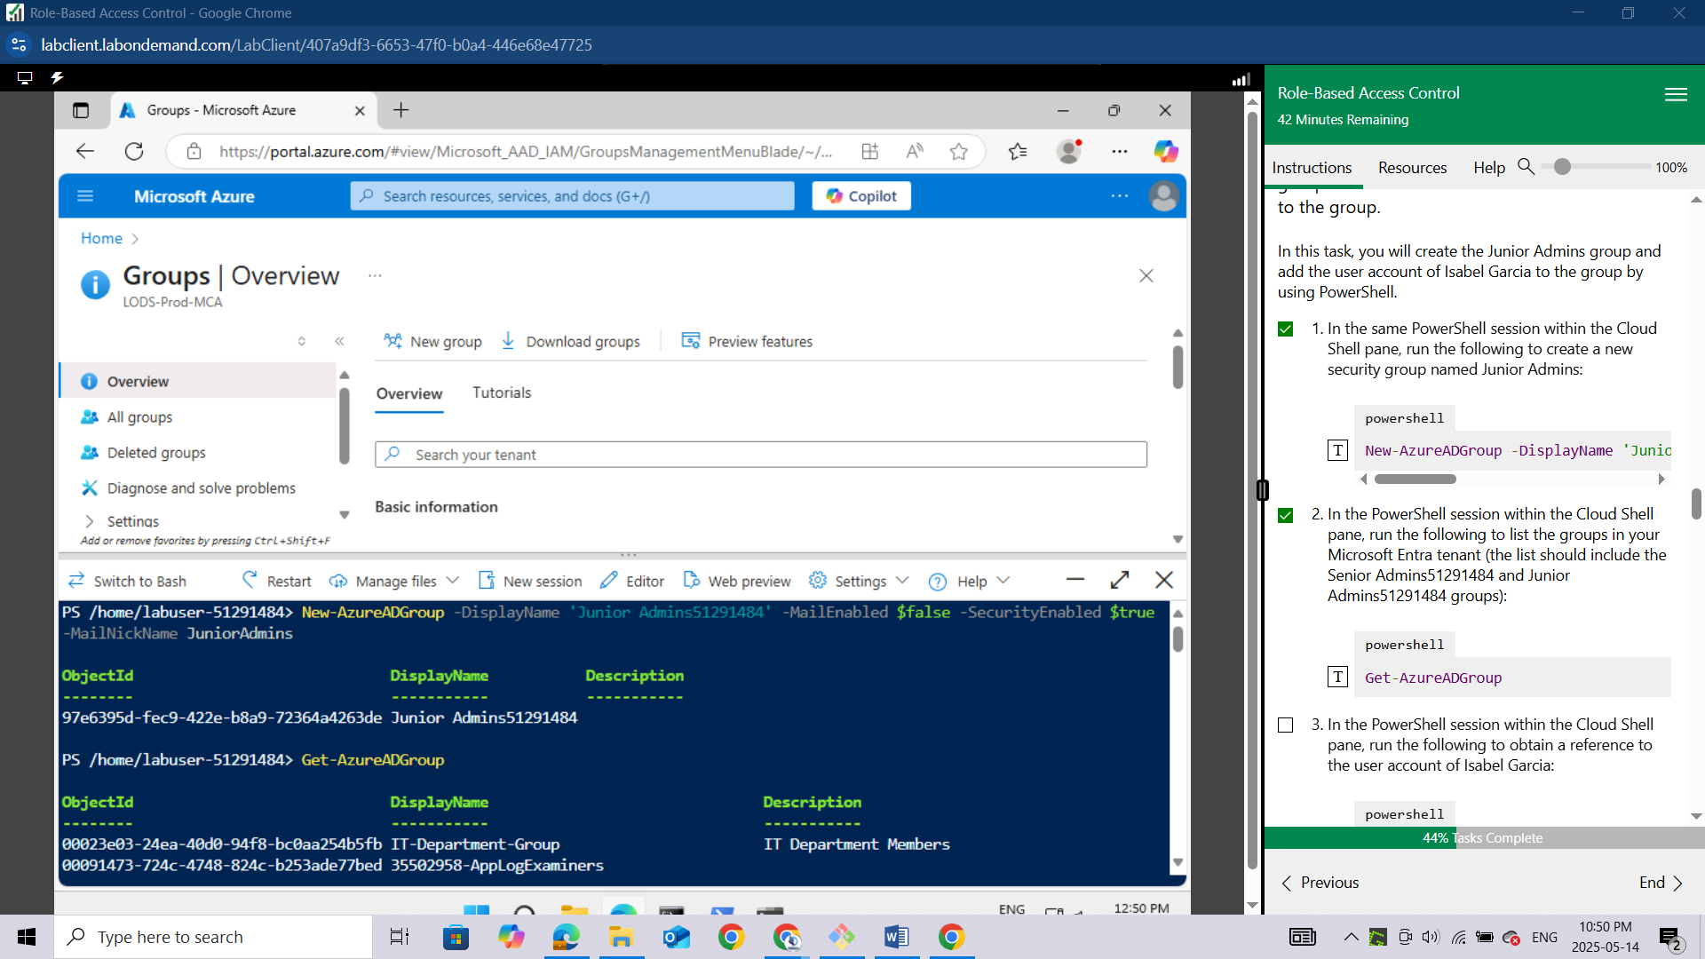

In the PowerShell session within the Cloud Shell pane, run the following to list the groups in your Microsoft Entra tenant (the list should include the Senior Admins51291484 and Junior Admins51291484 groups):

**powershell**

Get-AzureADGroup

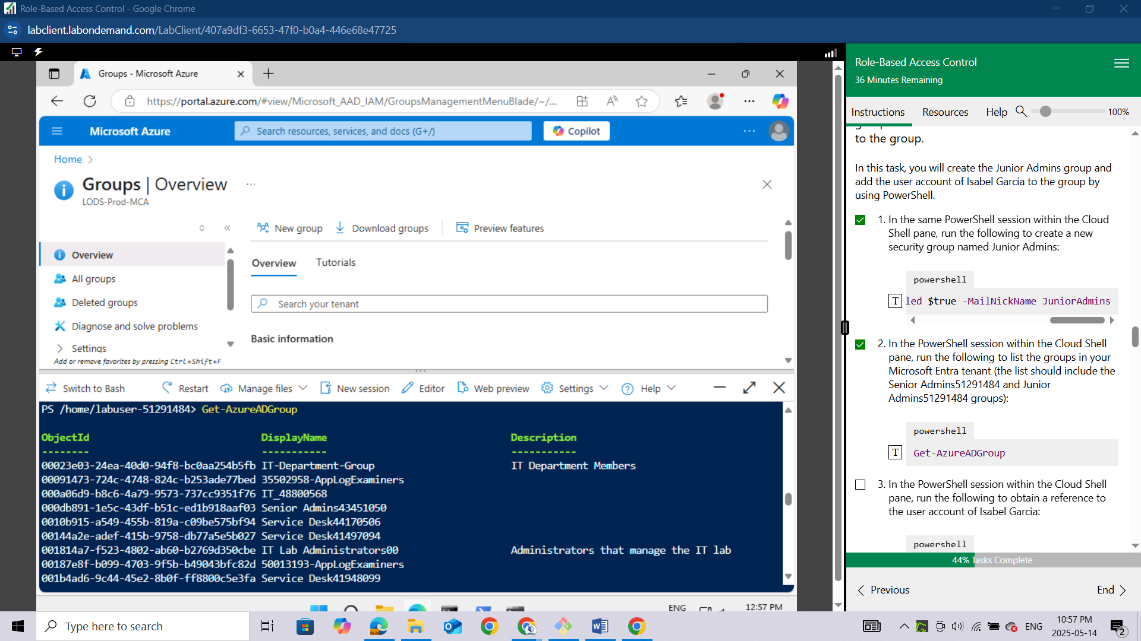

In the PowerShell session within the Cloud Shell pane, run the following to obtain a reference to the user account of Isabel Garcia:

**powershell**

$user = Get-AzureADUser -Filter "UserPrincipalName eq 'Isabel-51291484@LODSPRODMCA.onmicrosoft.com'"

In the PowerShell session within the Cloud Shell pane, run the following to add the user account of Isabel to the Junior Admins51291484 group:

**powershell**

Add-AzADGroupMember -MemberUserPrincipalName $user.userPrincipalName -TargetGroupDisplayName "Junior Admins51291484"

In the PowerShell session within the Cloud Shell pane, run the following to verify that the Junior Admins51291484 group contains the user account of Isabel:

**powershell**

Get-AzADGroupMember -GroupDisplayName "Junior Admins51291484"

***Result: You used PowerShell to create a user and a group account, and added the user account to the group account.***